Geometric Brownian Motion (GBM) – Real Life Example

Real-Life Example: Infosys Stock Price
An investor wants to estimate the future price of Infosys shares after 1 year. Stock prices do not move in a straight line. They move randomly every day, but generally grow over time. This type of movement is modeled using Geometric Brownian Motion (GBM).

Why GBM is Used in Real Life
- Stock prices never become negative.
- Returns are normally distributed.
- Prices follow a lognormal distribution.
- There is both growth (trend) and randomness.

Numerical Example
Given:
- Current Price (S₀) = ₹1,500
- Expected Return (μ) = 12%
- Volatility (σ) = 30%
- Time (T) = 1 year
- Random Z value = 0.5

GBM Formula
S_T = S_0 × e^((μ − 0.5σ²)T + σ√T Z)

Step-by-Step Calculation
S_T = 1500 × e^((0.12 − 0.5(0.30)^2)(1) + (0.30)(1)(0.5))
= 1500 × e^(0.225)
= 1500 × 1.252
Future Price ≈ ₹1,878
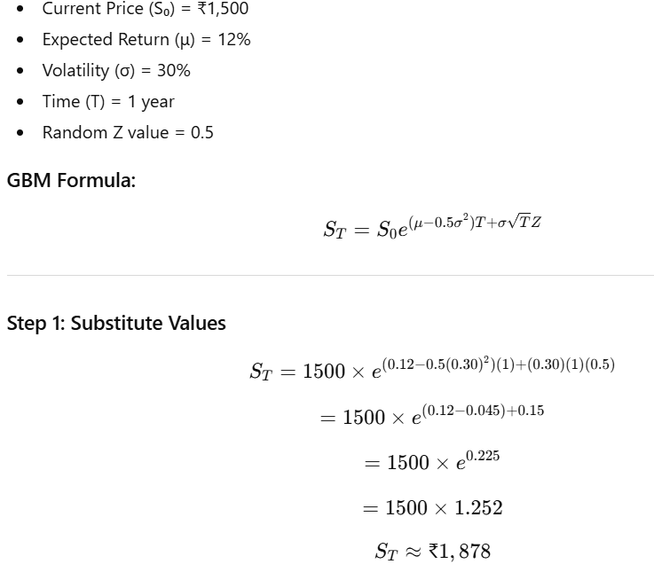

Interpretation
If market condition (Z = 0.5) is positive, the future price is approximately ₹1,878, which implies around 25% return. If Z were negative, the price would decrease.

Other Real-Life Uses of GBM
- Banking sector for risk estimation.
- Option pricing (Black-Scholes Model).
- Commodity price simulation.
- Cryptocurrency price modeling.

